Wednesday 17th July 2019

Dear Parents / Carers

School Mobile App

We have recently developed a new mobile app for parents which is linked to our school website. This app, once downloaded to your phone will give you direct notifications of any news and events at the school as well as delivery of all letters straight to your phone. You will also be able to access the calendar with ease. All notifications come through to your phone in the same way as you would be alerted to a text message.

[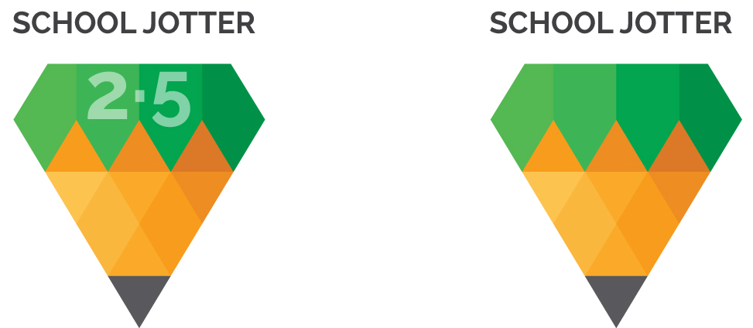](http://www.google.co.uk/url?sa=i&rct=j&q=&esrc=s&source=images&cd=&cad=rja&uact=8&ved=2ahUKEwj-vobR17vjAhVCLBoKHY-qDHsQjRx6BAgBEAU&url=http%3A%2F%2Fwww.google.co.uk%2Furl%3Fsa%3Di%26rct%3Dj%26q%3D%26esrc%3Ds%26source%3Dimages%26cd%3D%26ved%3D2ahUKEwiD2MnP17vjAhVixYUKHbtYCR4QjRx6BAgBEAU%26url%3Dhttp%253A%252F%252Fblog.schooljotter.com%252Fschool-jotter-2-5-one-stop-solution%252F%26psig%3DAOvVaw0skoRh5n8HeH03hE0Bd4wh%26ust%3D1563443630547139&psig=AOvVaw0skoRh5n8HeH03hE0Bd4wh&ust=1563443630547139)The app, which is completely free, can be downloaded from your services app store. Once downloaded, simply type Kings Mill School in the top search bar and this will take you straight to our site.

Some local schools have already been using the app for some time and have received a very positive response from parents.

The app has already been updated with exciting news stories, class activities, photo galleries and letters to parents so please ensure you download it as soon as possible. There are no limits to how many people can download the app making it available to parents, grandparents and childminders.

Any queries please contact the school office.

Yours Sincerely



Gail Lawton

Headteacher