Thursday 10th October 2019
Dear Parents / Carers

Kings Mill School & Residence will once again be hosting their annual Halloween Disco on Wednesday 30th October 2019 at 6pm in the Main School Hall. Tickets are £3.50 per child and include hot dog, chips and a juice. All children must be supervised by an accompanying adult. Additional refreshments will also be available to purchase for accompanying adults.

The night will include a DJ, spooky party games and prizes for the best costume. All tickets can be purchased from the main school office and must be done so by Thursday 24th October.

Hope to see you there for a frightfully fun night

Charlotte Dowson
Admin Assistant

Kings Mill School Halloween Disco
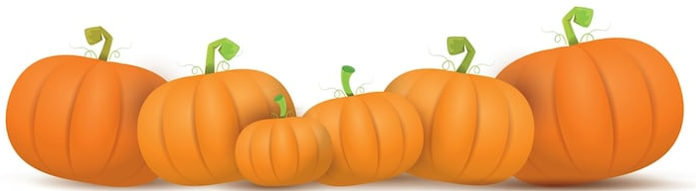
Wednesday 30th October 2019

Name:

Number of Tickets:

Amount Paid:

Signed:

Please return to the School Office by Thursday 24th October 2019

