Hot Chocolate Day
Raising money for the Yorkshire Air Ambulance
Thursday 5th March
9.30am - 11.30am in the hall
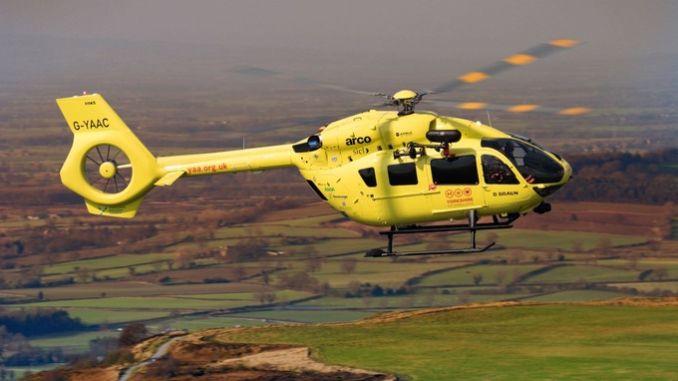
£1 each

