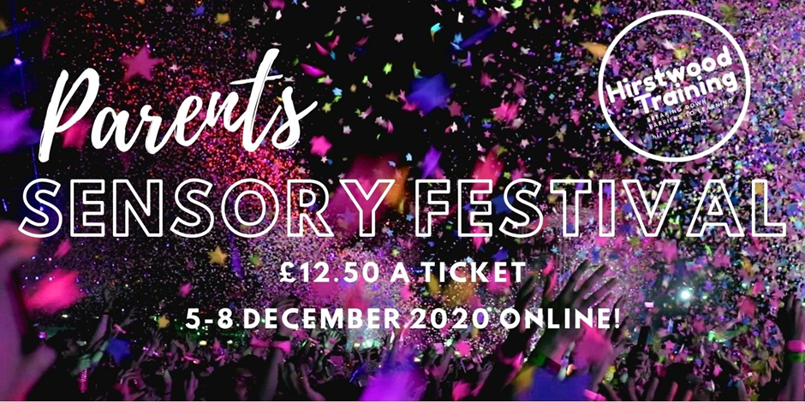
Introducing The Parents' Sensory Festival
5 to 8 December 2020
ONLINE!
https://hirstwood.com/parents-sensory-festival/

What a fabulous opportunity – a parents’ conference, designed and delivered with the intention to spend a day sharing practical sensory ideas that might just be exactly what you are looking for!

The live Festival will take place on Saturday 5th December 2020 and although we want you to be there we know that it’s not always possible. So the sessions will be recorded where possible and available to watch online until the evening of Tuesday 8th December 2020.

Our Parents’ Sensory Festival will be FUN and will inspire you to create simple sensory ideas and strategies to support your child and your family.

So get ready for sensory fun from messy play ideas, through technology suggestions to a series of top holiday gift suggestions. The day will finish with a question and answer session with our experienced panel… your chance to get an answer to that burning question!

Every session is carefully designed to offer ideas that can be used in everyday life. Resources will be signposted that work for any budget from items that can be found around the home to suggested purchases. Most importantly, we will explain why the choices are useful and how to have fun with your child using them.

Our video presentations and the recorded live sessions on the 5th December will be located in themed ‘Pavilions.’ These will be:
The Resources Pavilion
The Sensory Christmas Pavilion

So why not sign up, join in and enjoy the fun?
Here is the provisional agenda – (it may change!)

10.00 am Welcome and introduction. Richard Hirstwood will welcome you to the conference and explain how to get the best from the wide range of ideas that will be on offer.

10.15 am Live Session 1 – Go Noodle at Home!

10.30 am Live Session 2 – Sensory iPad and Android Apps

10.45 am Live Session 3 – Switch Activated Sensory Fun!

11.00 am Coffee and Visit the Pavilions

11.30 am Live Session 4 – Sensory stories

12.00 pm Live Session 5 – Playing at Home

12.30 pm Lunch and Visit the Pavilions

1.30 pm Live Session 6 – Using Lights Safely at Home

2.00 pm Live Session 7 – Top 10 Christmas Gifts

2.40 pm Live Session 8 – Panel Questions and Answers

3.15 pm Live Session 9 – What do you want for a future Sensory Parents’ Festival?

3.20 pm Close: Thank you and goodbyes!

