Thursday 26th November 2020

Dear Parents/Carers,

CHRISTMAS LUNCH

Kings Mill School will be having Christmas Lunch on Tuesday 15th December 2020. We will be following the traditional turkey and trimmings menu and asking all students and staff to wear their best Christmas jumpers for this festive day.

If your child normally brings a pack up and would like a Christmas lunch ordering at a cost of £2.30, please complete the slip below and return to school as soon as possible.

Regards

Gail Lawton

Gail Lawton
Headteacher

CHRISTMAS LUNCH

Please order my child a Christmas lunch on Tuesday 15th December
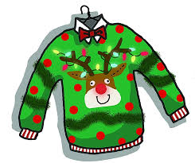
Child's Name____________________________________

I enclose £2.30 to cover the cost of the meal.

Return to Suzi in school office with £2.30 payment

