Furniture for Sale…
6th Form 3 Enterprise

Here in 6f3, as part of our Duke of Edinburgh Award, we have been up cycling furniture and these pieces are now ready to be on sale, here is a list of what is on offer………………………….

- 4 x chairs painted in sage green, offers around £25 for the set.
- Wooden chair painted in chalk grey offers between £5-£10.
- Black chair covered with flamingo print fabric £10.
- Brown wooden chair with pheasant print fabric offers between £15-£20
- 2 children’s wooden chairs - will accept offers between £10-£15 for the pair.
- Mountable wall shelf £5

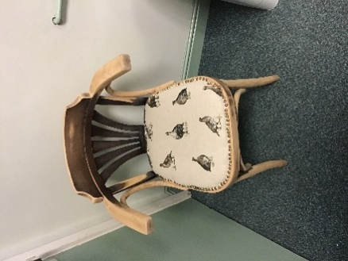
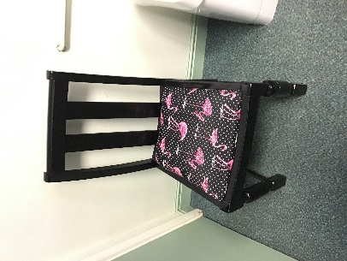
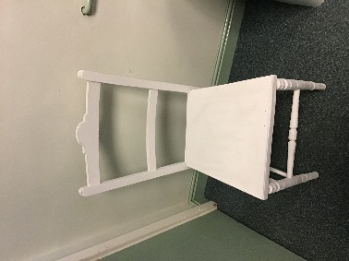

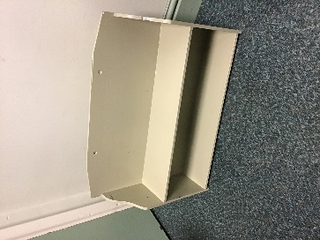
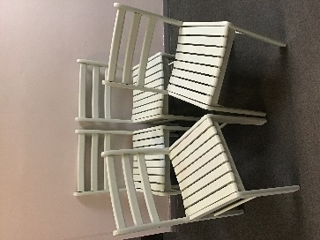
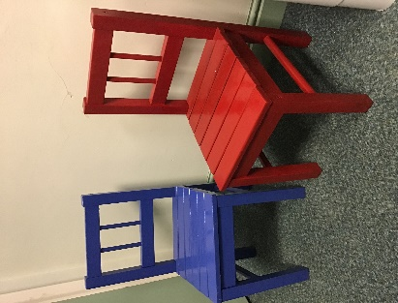

Thank you for looking and hopefully purchasing! If any of the items are of interest to you, please email susan.baxter@kingsmill.eriding.net

