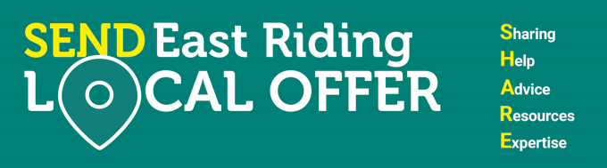

Neurodiversity Services
Neurodiversity services support children and young people with support needs for autism, ADHD, learning disability, sensory process disorder, cerebral palsy, Downs Syndrome and much more.
As a system, Hull and East Riding health and care partners have recognised they need to change and improve how children and their families access and receive support, and how services are provided. Following feedback received from children and young people and their parents, a series of service reviews and events were undertaken in 2019. These events produced an evaluation report in 2020 with an agreed vision, values and overarching service model for local services that support neurodiversity.
We would like to invite parents of children and young people with neurodiverse needs to join us in a series of virtual joint Hull and East Riding focused discussion sessions. We want parents to co-produce the development of the new approach for the delivery of the Hull and East Riding Children’s Neurodiversity Service.
Below you will find a link to the promotional video
https://youtu.be/GLdq6QVO910
The Eventbrite links to the neuro sessions are as follows
Tuesday 15th June | 10:00am – 12 noon | Access and Needs | https://www.eventbrite.co.uk/e/156727942495
Thursday 17th June | 19:00pm – 21:00pm | Access and Needs
Tuesday 29th June | 10:00am – 12 noon | Information and advice | https://www.eventbrite.co.uk/e/156862575185
Thursday 01st July | 19:00pm – 21:00pm | Information and advice
Tuesday 6th July | 10:00am – 12 noon | Care co-ordination | https://www.eventbrite.co.uk/e/156863174979
Thursday 8th July | 19:00pm – 21:00pm | Care co-ordination
Tuesday 13th July | 10:00am – 12 noon | Outcomes and follow-up | https://www.eventbrite.co.uk/e/156865489903
Thursday 15th July | 19:00pm – 21:00pm | Outcomes and follow-up
Please note session zoom links will only be sent to people who have signed up using the links above the day befor

