Monday 5th July 2021

Dear Parents / Carers

On Thursday, 6th Form 3 will be taking part in a sponsored walk over the Humber Bridge to raise funds for our chosen charity MIND. This will be our last walk for the Duke of Edinburgh Physical Challenge that we have been doing weekly over the past term. We have chosen MIND as many more young people and adults are struggling with their mental health due to the impact of the coronavirus and restrictions.

With your generosity we are hoping to raise £50 - £75 which can be paid in cash to the school office. Please put all donations in a sealed envelope with Humber Bridge Sponsored Walk on the front.

We thank you in advance for your continued support and keep an eye out for photos and next week’s follow up article.

Best Wishes

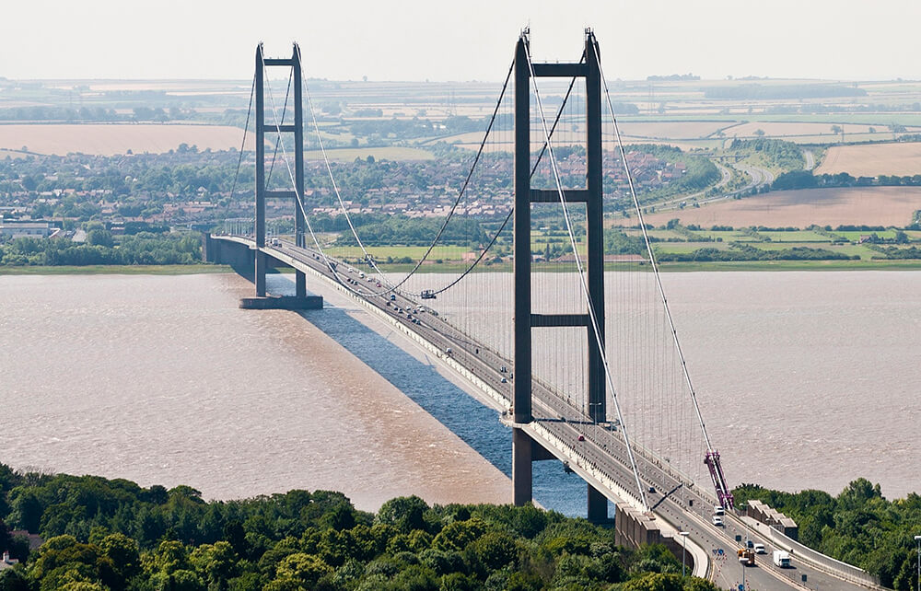
Sixth Form Three

