18th October 2021

Dear Parents/ Carers,

We would like to remind you that we must be able to contact you or another responsible adult when your child is with us. Please make sure we have up-to-date contact numbers.

This is especially important if you are going away and your child will be in school or residence. Please contact the class teacher and they will provide a reminder of the information we need.
It is also essential that our medical care plans are up to date. If anything changes regarding your child’s medication administered whilst at school or the care they need for a medical condition, please ask the office for a new Pupil Medical Information Form to fill in.

Finally, if anyone else is picking up your child we must know about this in advance and they will be asked to provide photo ID upon collection.

Thank you for working with us to keep all our pupils safe.

Yours Faithfully

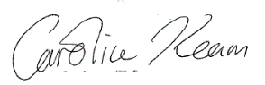

Caroline Keam
Assistant Head and Health and Safety officer

