22.03.2022

Dear Parents/Carers

**COVID-19 Update**

I am writing to update you on the current situation in school with regards to COVID rates. I had really hoped that I wouldn’t be writing any more COVID related letters to you!

As a special school we have a collective responsibility to work together to protect those most vulnerable whilst also protecting face-to face education for our children and young people. We have continued with our control measures:

1. Ensuring good hygiene for everyone (hand hygiene & respiratory hygiene)

2. Maintaining appropriate cleaning regimes

3. Keeping occupied spaces well ventilated

4. Following public health advice on testing, self-isolation and managing confirmed cases of COVID-19

The local authority, alongside public health has advised staff and where possible pupils to continue regular twice weekly testing (something that I am led to believe will continue on after 1st April).

Since the 14th March, we have been seeing a steady increase in the number of staff and pupils testing positive. This led to two classes (6th form and Primary) reaching their threshold of cases and forced us to step up our preventative measures to try and help reduce the spread of infection further. The classes moved to ‘Plan B’ and a reduced attendance timetable, which allowed us to keep classes open with reduced staff cover. The number of staff testing positive across the school also meant that there was a strain on our supply cover. One class is back up and running as usual, with the other hoping to return by the middle of the week.

Those classes reaching their threshold and moving to Plan B are also returning to working within a bubble, eating in the classroom and not joining assembly.

Unfortunately, the weekend brought a further flurry of positive cases, which is now impacting a class in the senior department. They too are moving to a Plan B, effective from tomorrow. We have been working directly with the families of those classes affected but as we have now reached this point I felt it appropriate to speak with you all.

**Current COVID-19 self -solation advice**

I would like to take this opportunity to remind you, that although the rules regarding isolation have now changed, children and young people with COVID-19 should not attend school while they are infectious. They should take an LFD test from 5 days after their symptoms started (or the day their test was taken if they did not have symptoms), followed by a further test the next day (day 6). If both of these tests are negative, they should return to school as normal as long as they feel well enough and do not have a temperature. Children should not return to school until they have had two consecutive negative LFDs or they reach day 11, when they are able to return even if their LFD is still positive (as they are highly unlikely to be infectious at this point).

If you are unsure about when your child should/should not be in school, please contact the school office of your class teacher for advice.

The diagram below may help:

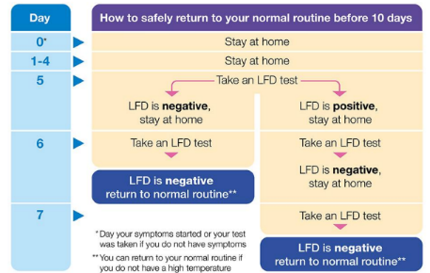

Due to the nature of the vulnerability of some of our pupils our staff, at this current time, are **expected** to follow this guidance and not return to work. Unfortunately, most staff are not getting two consecutive negative results until day 8 or 9.

**Additional symptoms**

Other symptoms linked with COVID-19 include shortness of breath, fatigue, loss of appetite, muscle ache, sore throat, headache, stuffy or runny nose, diarrhoea, nausea and vomiting. Any of these symptoms may also have another cause but it is worth bearing this in mind if your child is feeling unwell.

I cannot thank you enough for the support and understanding that you have shown throughout the past two years. The health, safety and wellbeing of our children and staff is extremely important to us.

I look forward to being able to inviting you to join us at the end of the term to celebrate our Stars of the term – fingers crossed that nothing gets in the way!

Sincere regards