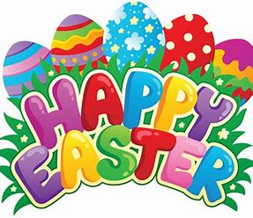

8th April 2022

Happy Easter

Visitors in school
What a lovely end to the spring term. We were excited to have the whole school together, for the first time in 2 years, to celebrate the star of the term awards. We took the plunge to invite parents of those children receiving an award and opened up the coffee shop. It was quite an emotional and joyous assembly and the pupils were amazing. As a result, we are all set to resume our star of the week praise assemblies on a Friday morning. Parents, families and friends will be able to stop and chat over a drink and a slice of cake. Keep an eye on your class DoJo for your invitation.
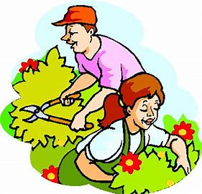
Gardening Club
Now that spring has sprung we are hoping to get the friends of Kings Mill gardening club back up and running. This is being led by Libby and takes place on a Friday morning and coincides with the café opening. Nobody can work without reinforcement!
If you are interested or know someone that might be please do get in touch with school and we will pass your details on.

Learning to live with Covid-19:
Once again the Covid rules have changed so what does this look like for us at school?
Covid-19 is now being viewed alongside other respiratory infections. The symptoms of COVID-19 and other respiratory infections are very similar. It is not possible to tell if you have COVID-19, flu or another respiratory infection based on symptoms alone. Most people with COVID-19 and other respiratory infections will have a relatively mild illness, especially if they have been vaccinated.
Symptoms of COVID-19, flu and common respiratory infections include:
- continuous cough
- high temperature, fever or chills- a high temperature means you feel hot to touch on your chest or back (you do not need to measure your temperature)
- loss of, or change in, your normal sense of taste or smell
- shortness of breath
- unexplained tiredness, lack of energy
- muscle aches or pains that are not due to exercise
- not wanting to eat or not feeling hungry
- headache that is unusual or longer lasting than usual
- sore throat, stuffy or runny nose
- diarrhoea, feeling sick or being sick

So, children who have Covid (if you have been able to test them) or those with symptoms, should stay at home whilst they are unwell and avoid contact with other people where they can. If they are testing positive, they can return to school 3 days after they took the test, as long as they don’t have a temperature and are feeling well enough. If your child is simply unwell, they should return to school once feeling better.
For staff the current guidance is that they will need to stay at home for 5 days after a positive test. This is because adults tend to be infectious to other people for more time that children are. School staff are being asked to continue to test twice weekly, due to the nature of the pupils that attend Kings Mill.

Public Health England inform us that all childhood diseases and infections such as flu are on the rise with young children particularly having less immunity as they haven't been exposed to infection over the last 2 years. We ae being asked to report all diseases including non-notifiable ones like chickenpox. Alongside this we will continue to report all positive Covid results.

If you are in any doubt about your child attending school, please contact us and we will be able to advice.

Celebrations
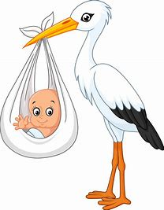
We have had a busy term with three babies born, congratulations go out to Caitlin, Amy and Beth.

We also have a wedding taking place on Easter Saturday, Joe and Sarah tie the knot and we wish them both every happiness.

Finally, I would like to thank you all for your continued support for the school and I wish all children, parent/carers, staff and Governors a very Happy Easter.

Best wishes
Alison

